Project Phase 2

CS 513: Theory and practice of data cleaning

Team Members:

Goutam Debnath(goutamd2@illinois.edu)

Debabrata Biswas(dbiswas3@illinois.edu)  
Rohit Narula(rnarula2@illinois.edu)

Table of Contents

Introduction 1

Objective 1

Data Cleaning Process Detail: 1

Data Cleaning with OpenRefine 1

**MarketName** 2

Data Correction using Python 11

Exploring the distribution of farmers markets in the US. 18

# Introduction

The project team has identified the [Farmer’s Market Data](https://www.ams.usda.gov/local-food-directories/farmersmarkets) as a candidate for CS-513 Theory and Practice of Data Cleaning project submission. The following part of the document elaborates the procedure, steps, and exploratory data analysis to reach the objective of the project.

# Objective

U1:

U0:

# Data Cleaning Process Detail:

The farmer’s market dataset has been provided as a csv/text format. The following major steps have been performed:

1. Use [OpenRefine](https://openrefine.org/) tool to clean important and obvious data issues visible naturally. OpenRefine is the go-to tool for its ease of use and simplicity and can be used on a huge dataset out of the box.
2. Once the data has been cleaned satisfactorily, it’s the time for populating missing us Zip code data. We have identified Python’s [uszipcode](https://pypi.org/project/uszipcode/) package as a free tool to accomplish the task.
3. Once the data is further cleaned, we rely on SQL to verify the sanctity of the data and run through various SQL integrity constraint checks to ensure the data is clean and trustworthy to answer our base use case.
4. TODO @Rohit exploratory data

# Data Cleaning with OpenRefine

With OpenRefine, data will be clustered if they are in similar text or reformatted to keep consistency of data.

Firstly, all column data should be trimmed and collapsed if they have consecutive white spaces.

Next, county, city, states names are inconsistent. Some of them are in uppercase while others are not. They need to be converted into same format by clustering function.

Date fields are saved as String so we need to convert them to date type so they are all converted to proper date format.

**MarketName**

- Trim leading and trailing white space.

- Collapse consecutive white spaces.

- Use text facet and cluster by using key collision method and fingerprint keying function.

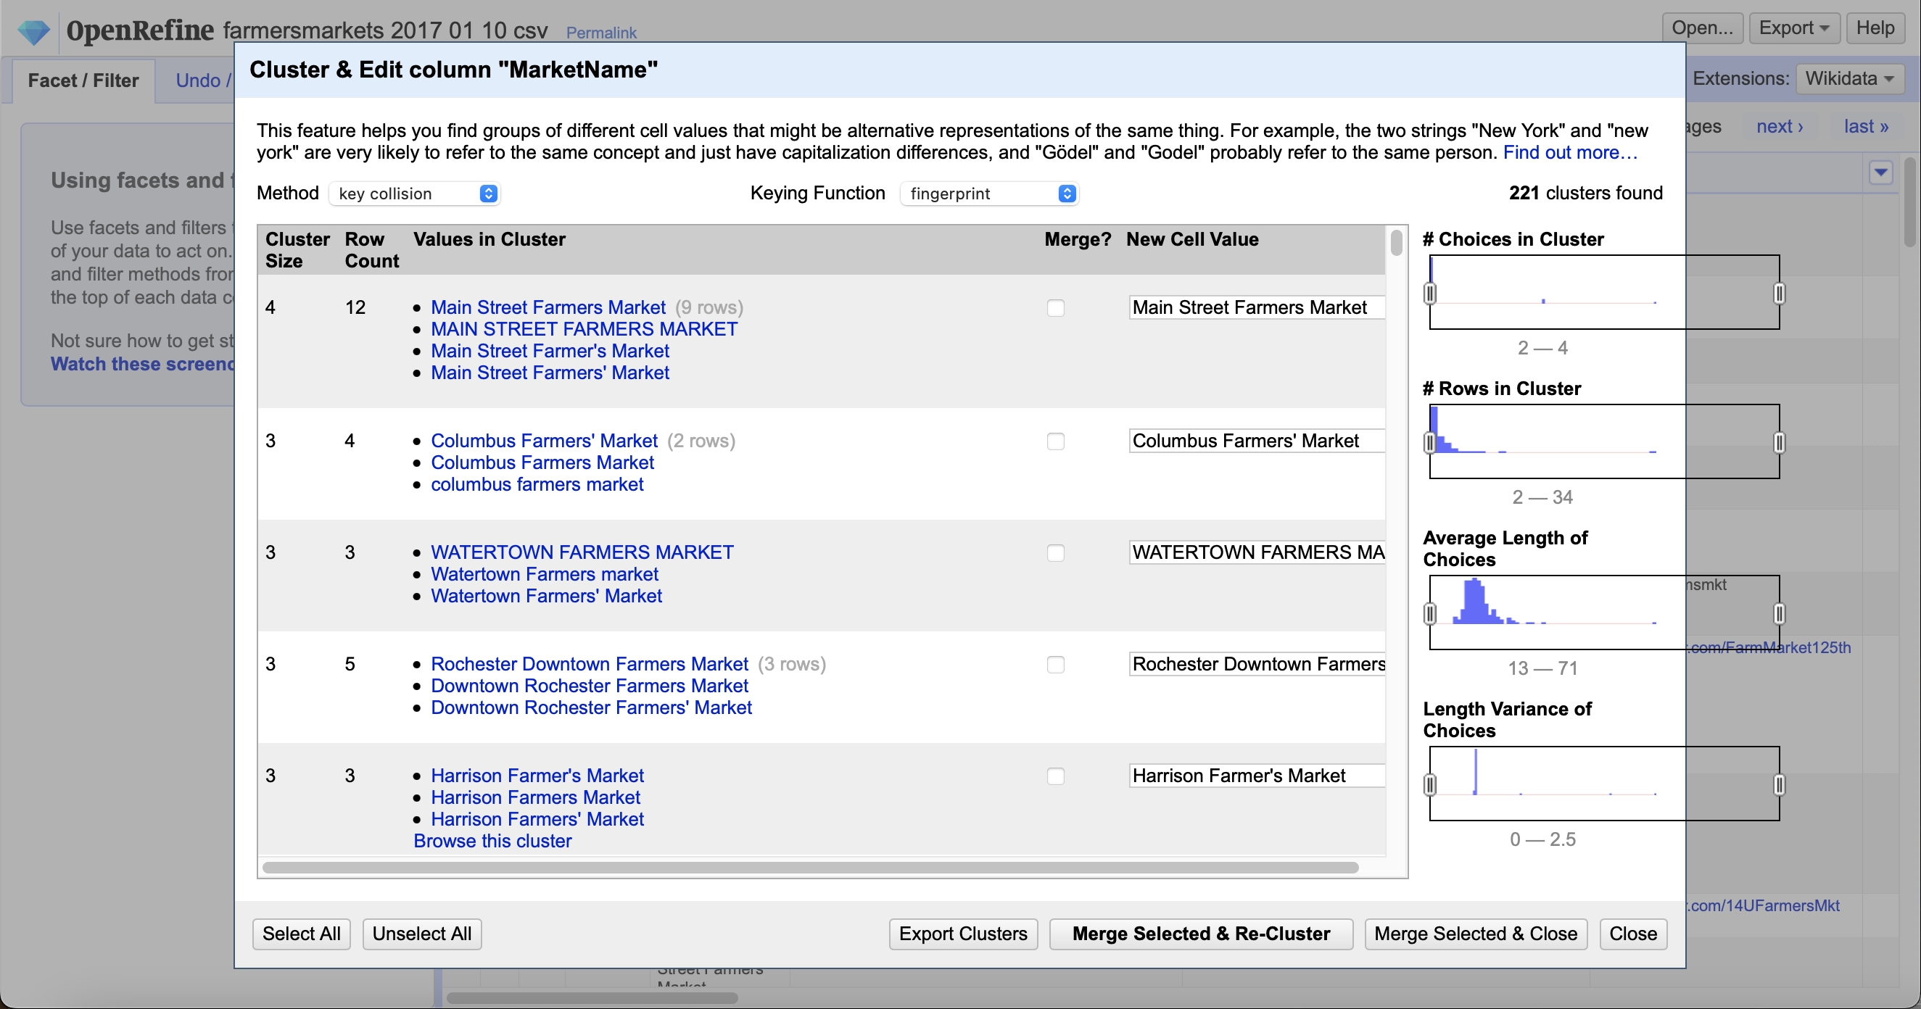

- Use text facet and cluster again by using key collision method and ngram-fingerprint, except those have distinct different names such as Nashville F.A.R.M. II and Nashville F.A.R.M. III.

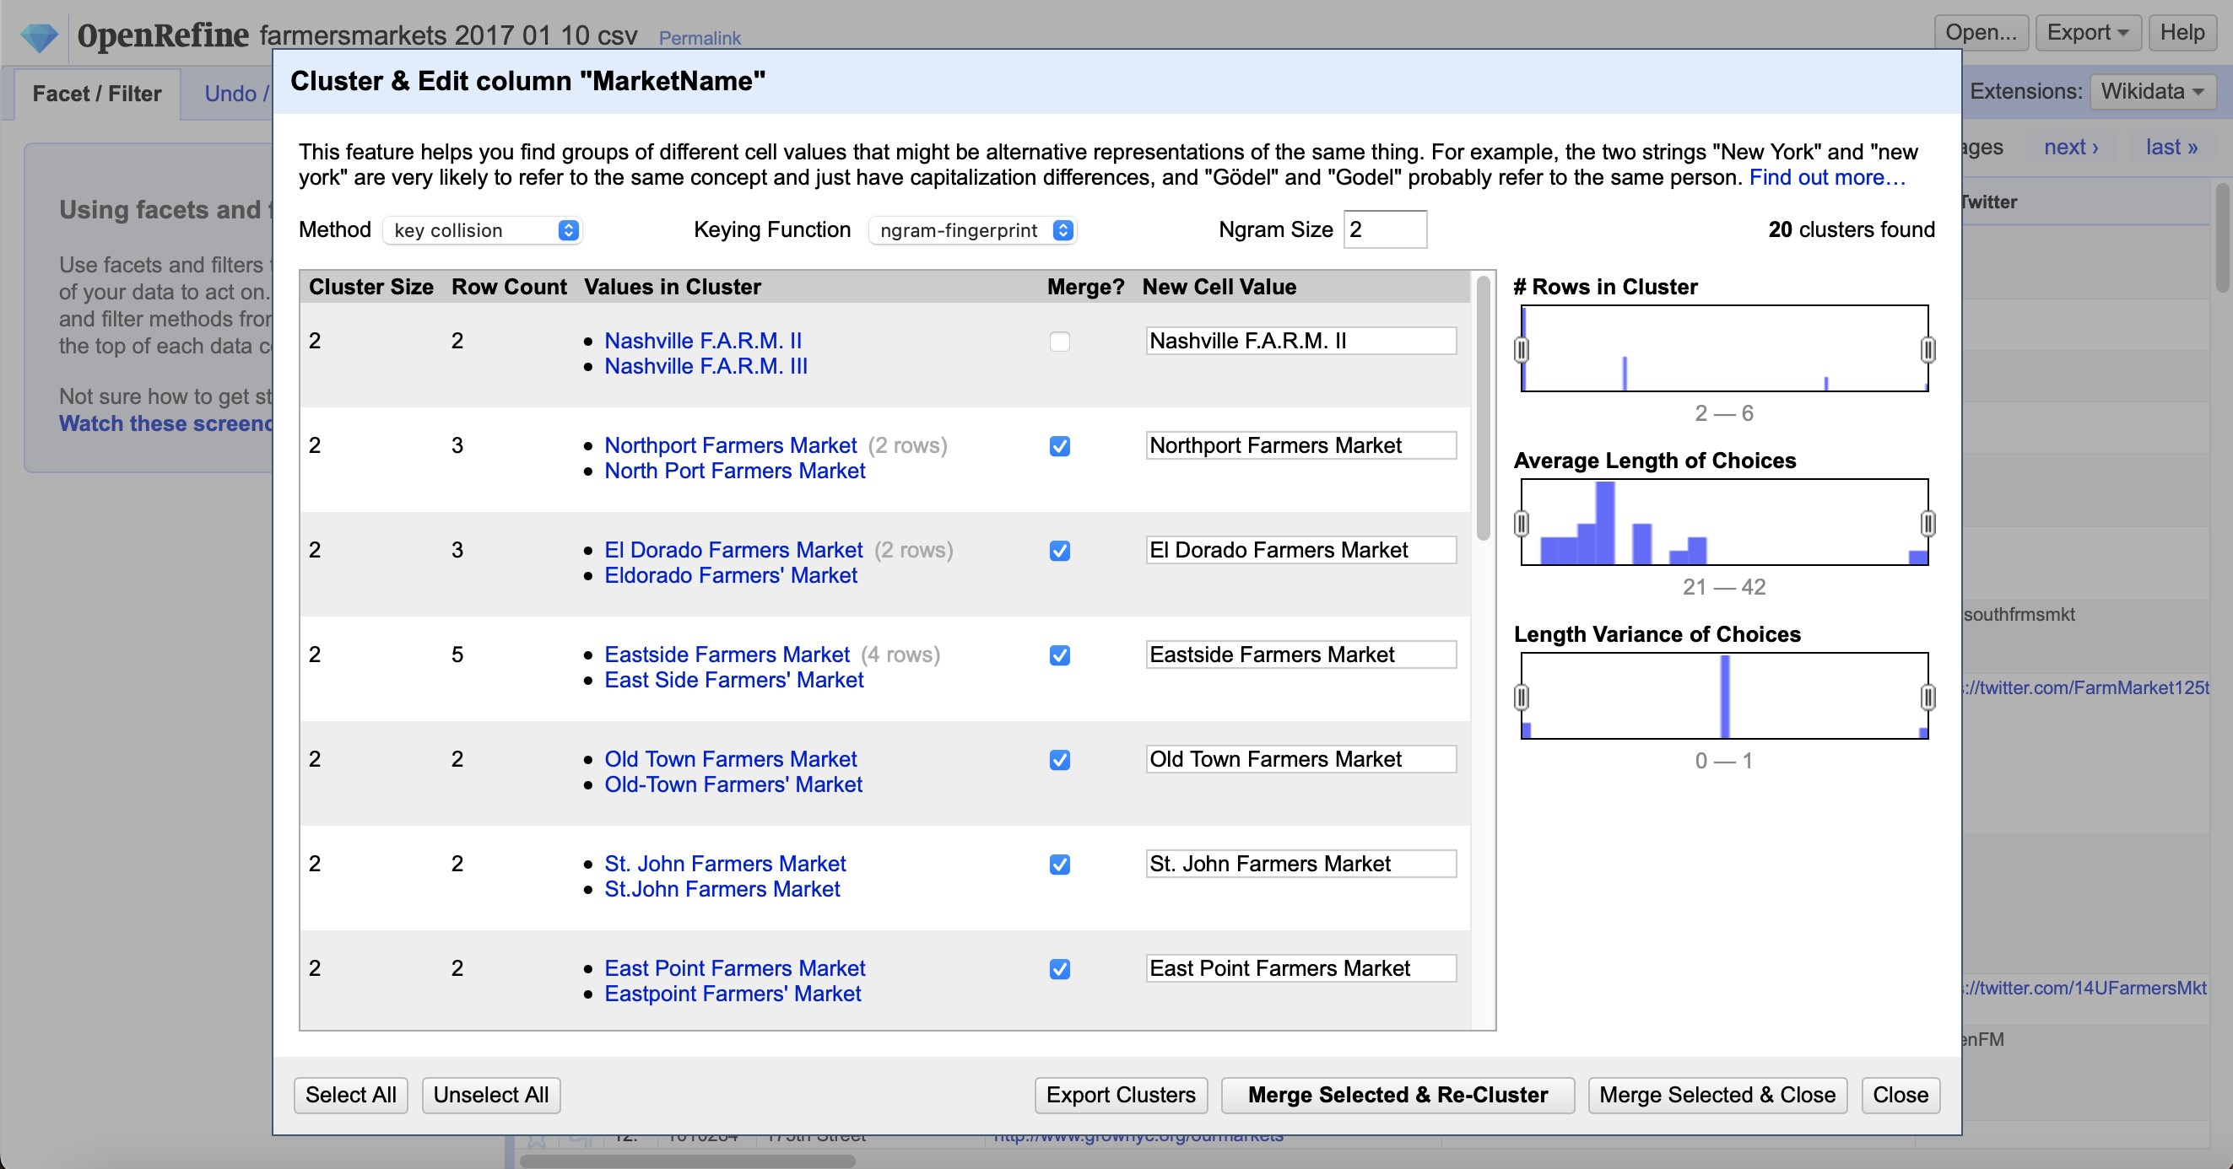

**Street:**

- Trim leading and trailing white space.

- Collapse consecutive white spaces.

- Use text facet and cluster by using key collision method and fingerprint keying function.

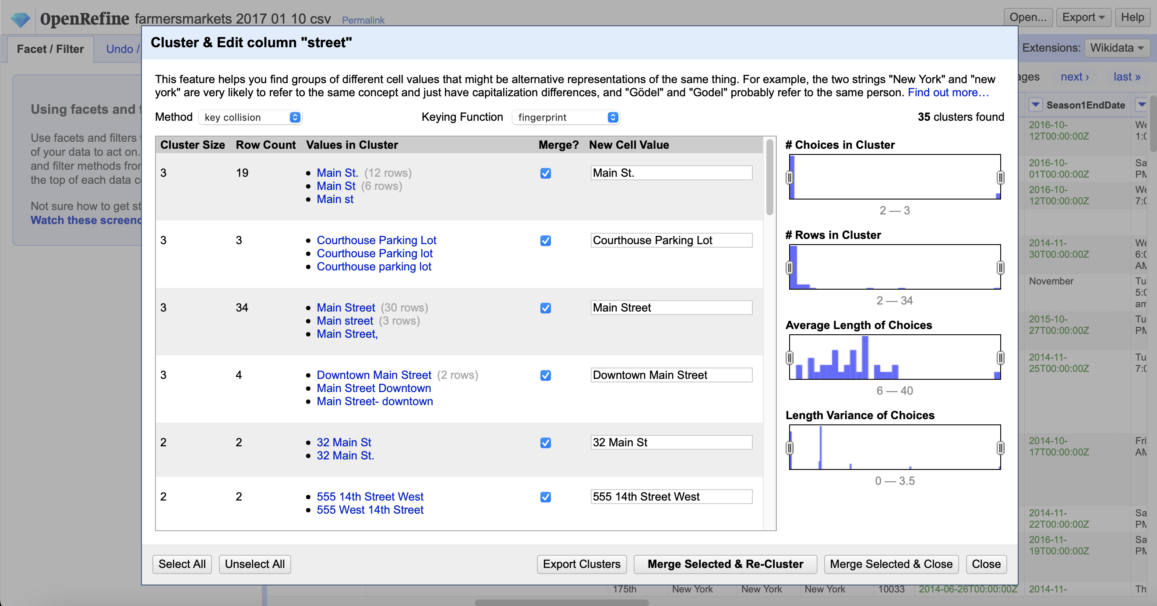

- Use text facet and cluster again by using key collision method and ngram-fingerprint except values like Community Center and Unity Community Center.

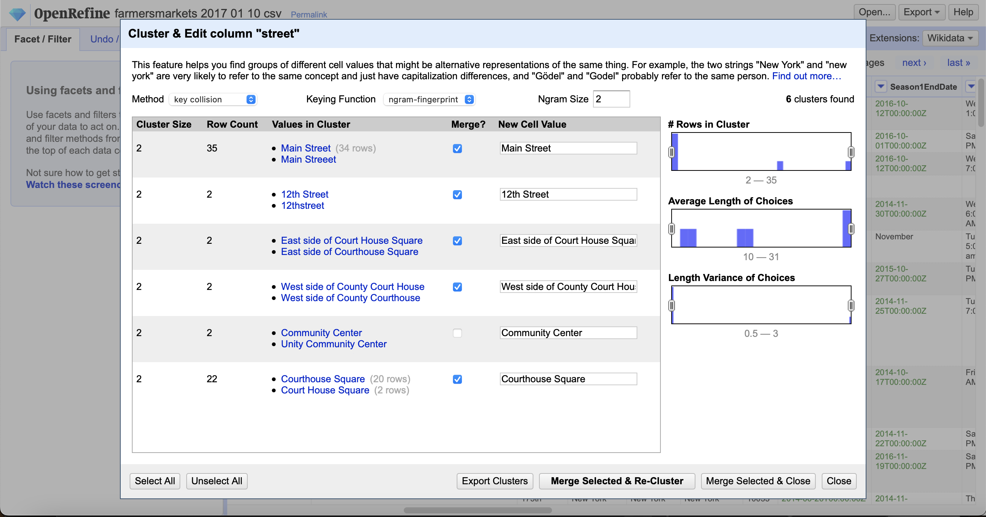

**City:**

- Trim leading and trailing white space.

- Collapse consecutive white spaces.

- Use text facet and cluster by using key collision method and fingerprint keying function.

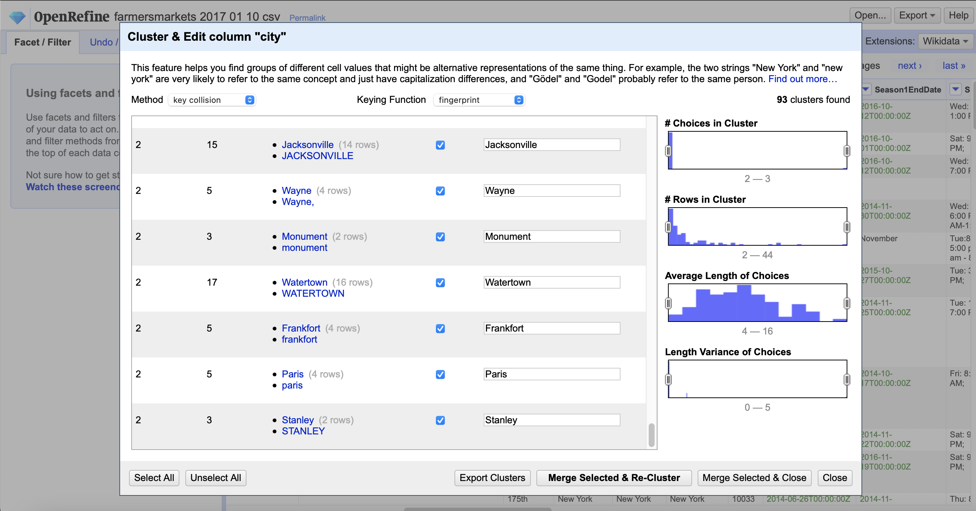

- Use text facet and cluster again by using key collision method and ngram-fingerprint

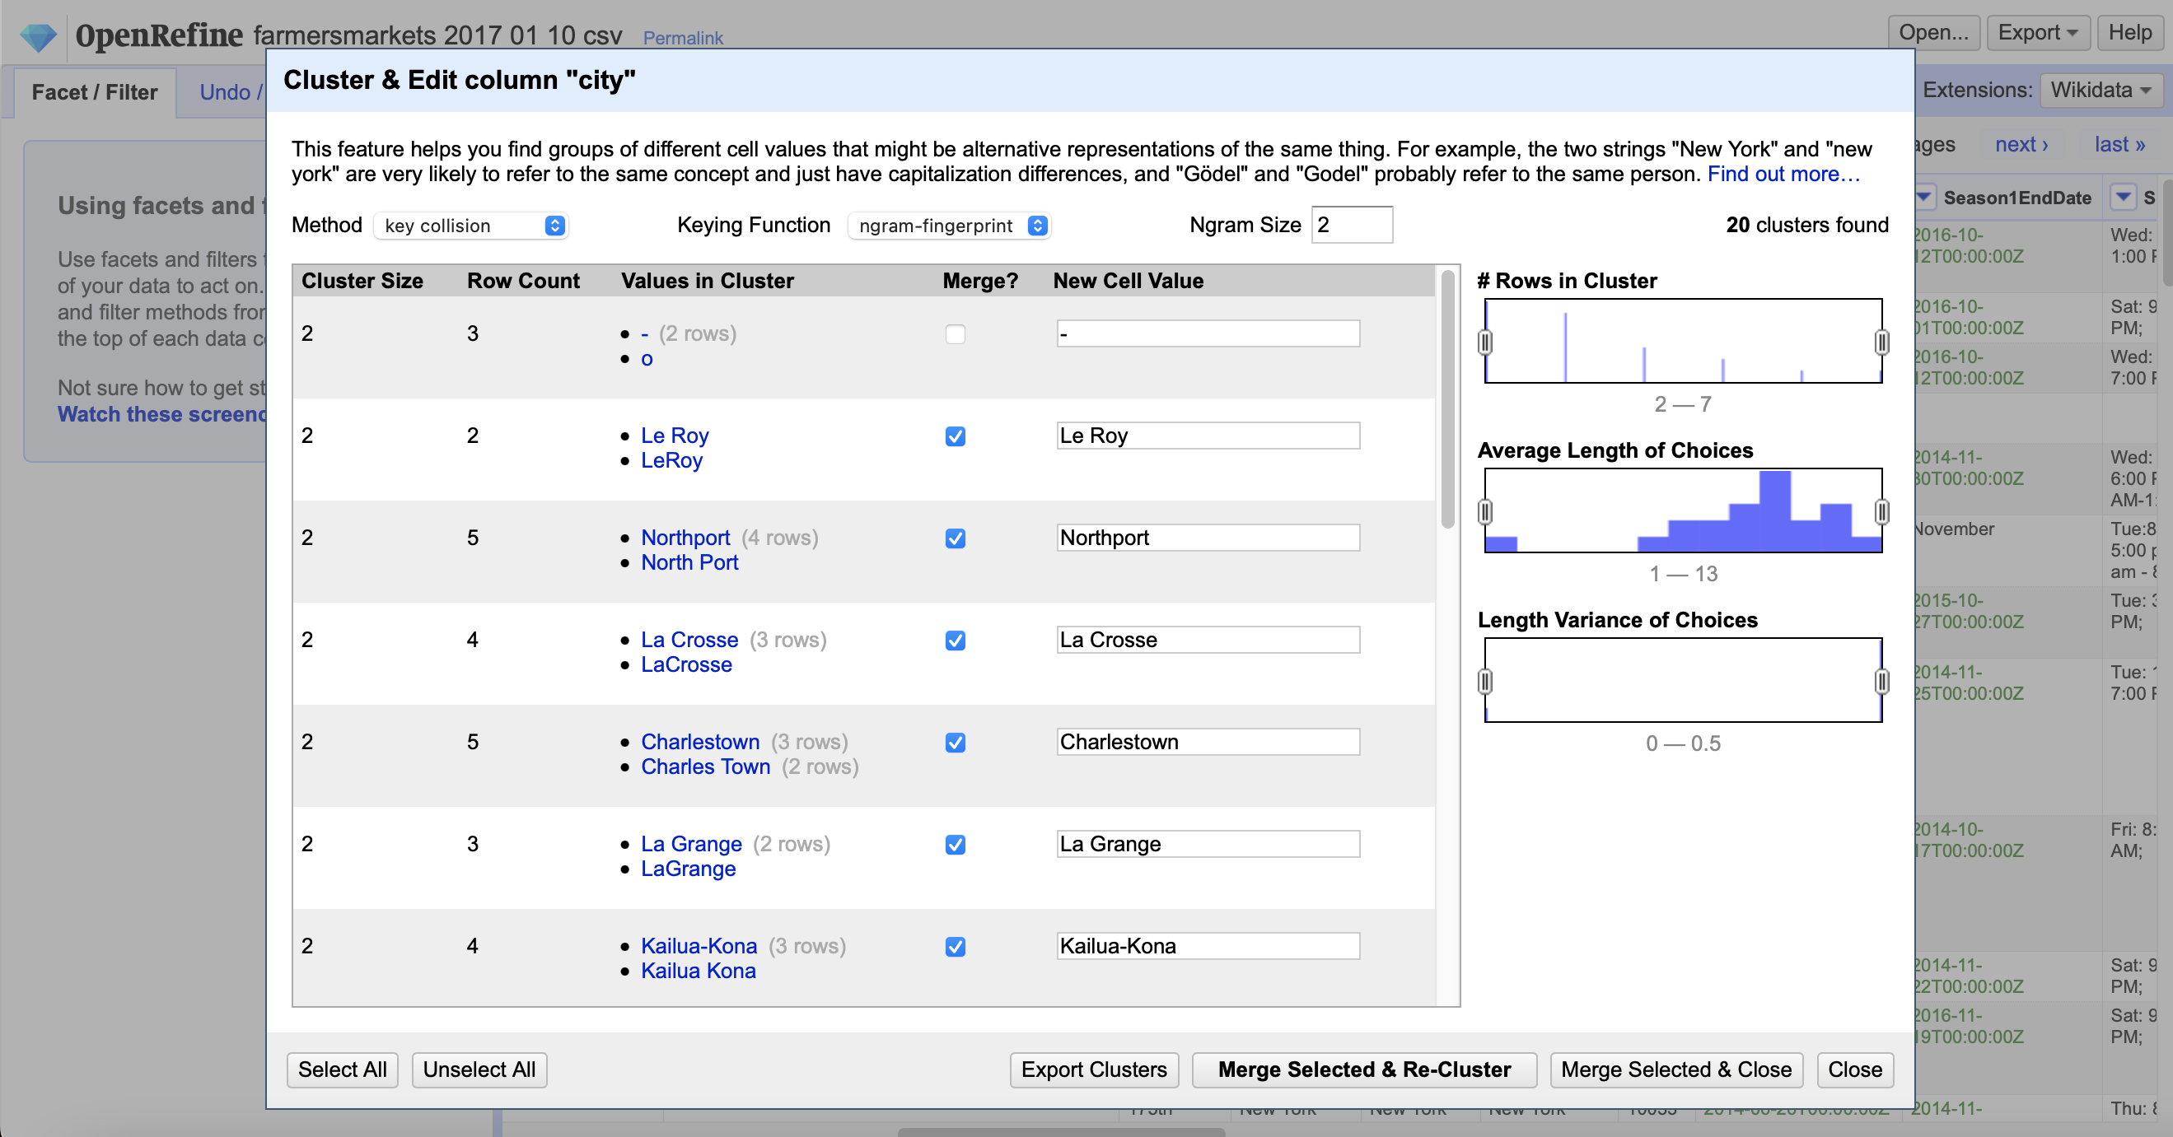

**County:**

- Trim leading and trailing white space.

- Collapse consecutive white spaces.

- Use text facet and cluster by using key collision method and fingerprint keying function.

- Use text facet and cluster again by using key collision method and ngram-fingerprint

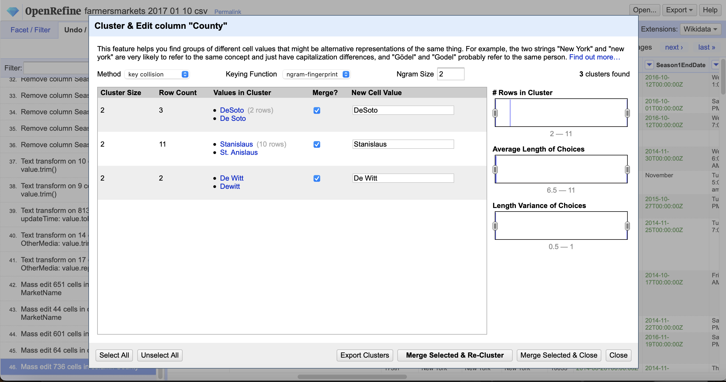

**Zip Code:**

- Trim leading and trailing white space.

- Collapse consecutive white spaces.

- Convert any string values to blank using GREL.

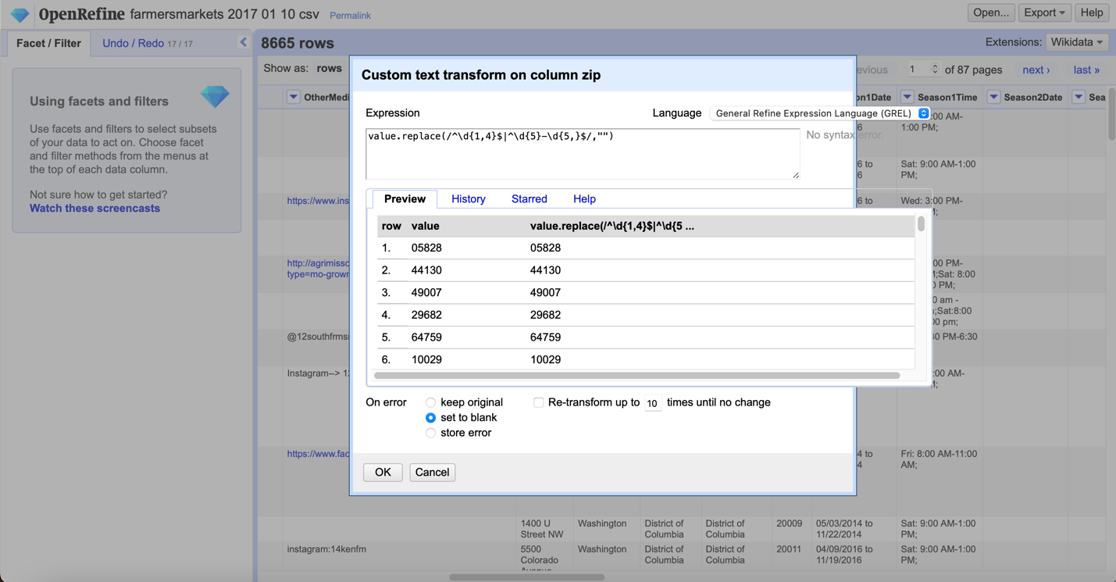

**Website**

- Trim leading and trailing white space.

- Use text facet and cluster by using key collision method and fingerprint keying function.

- Use text facet and cluster again by using key collision method and ngram-fingerprint

**Facebook**

- Trim leading and trailing white space.

- Collapse consecutive white spaces.

- Eliminate ‘N/A’ or ‘none’ string values by using clustering function.

- Use text facet and cluster by using key collision method and fingerprint keying function.

- Use text facet and cluster again by using key collision method and ngram-fingerprint

**Twitter**

- Trim leading and trailing white space.

- Eliminate ‘N/A’ or ‘none’ string values by using clustering function.

- Use text facet and cluster by using key collision method and fingerprint keying function.

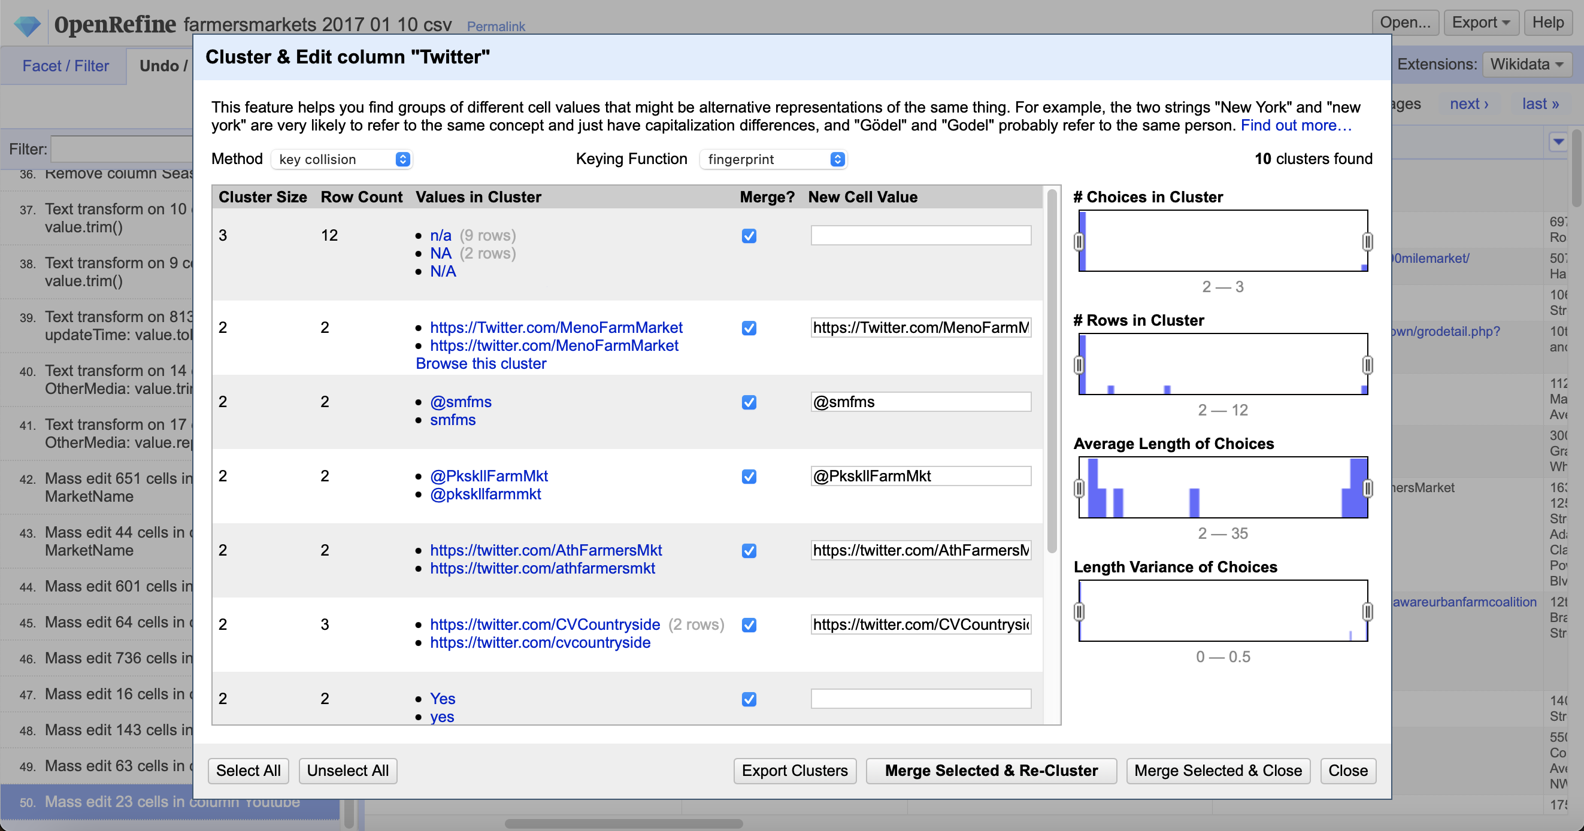

**Youtube**

- Trim leading and trailing white space.

- Eliminate ‘N/A’ or ‘none’ string values by using clustering function.

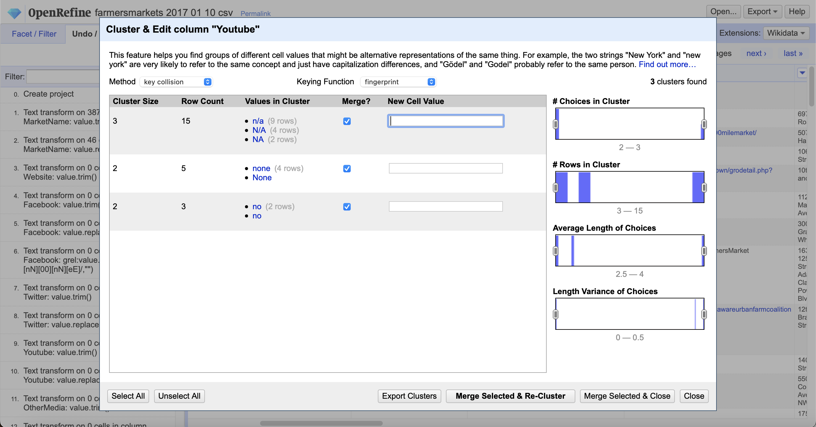

**OtherMedia**

- Trim leading and trailing white space.

- Collapse consecutive white spaces.

**Season1Date**

- Trim leading and trailing white space.

- Collapse consecutive white spaces.

- For better use and clear view, split into two columns: one is start date “Season1StartDate”, and the another is end date “Season1EndDate”.

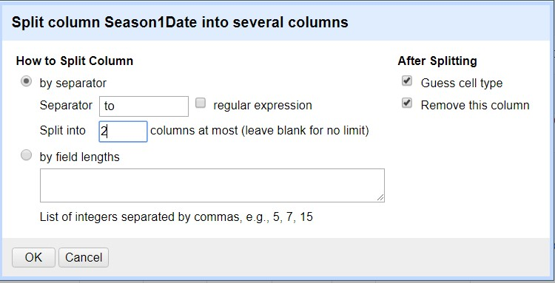

**Season1StartDate**

- Change the date type to date

**Season1EndDate**

- Change the date type to date

**Season2,3,4Date and Season2,3,4Time**

- Considering that about 95% of these columns are blank, drop the columns for decreasing sparsity of data.

**x**

- Trim leading and trailing white space.

**y**

- Trim leading and trailing white space.

**updatedTime**

Change the date type to date

# Data Correction using Python

Further data cleaning and correction to preliminary steps above will be done using custom python scripts.

Below are the cleanup activities:

1. Find all the records which matches any condition below having Longitude(x) and Latitude(y) populated:

1. Either CITY, COUNTY, STATE, ZIP is Blank.

2. Either CITY, COUNTY, STATE has a Number in it.

3. The ZIP has alphabets in it or not having DDDDD or DDDDD-DDDD format.

Below is how the raw data looks like:

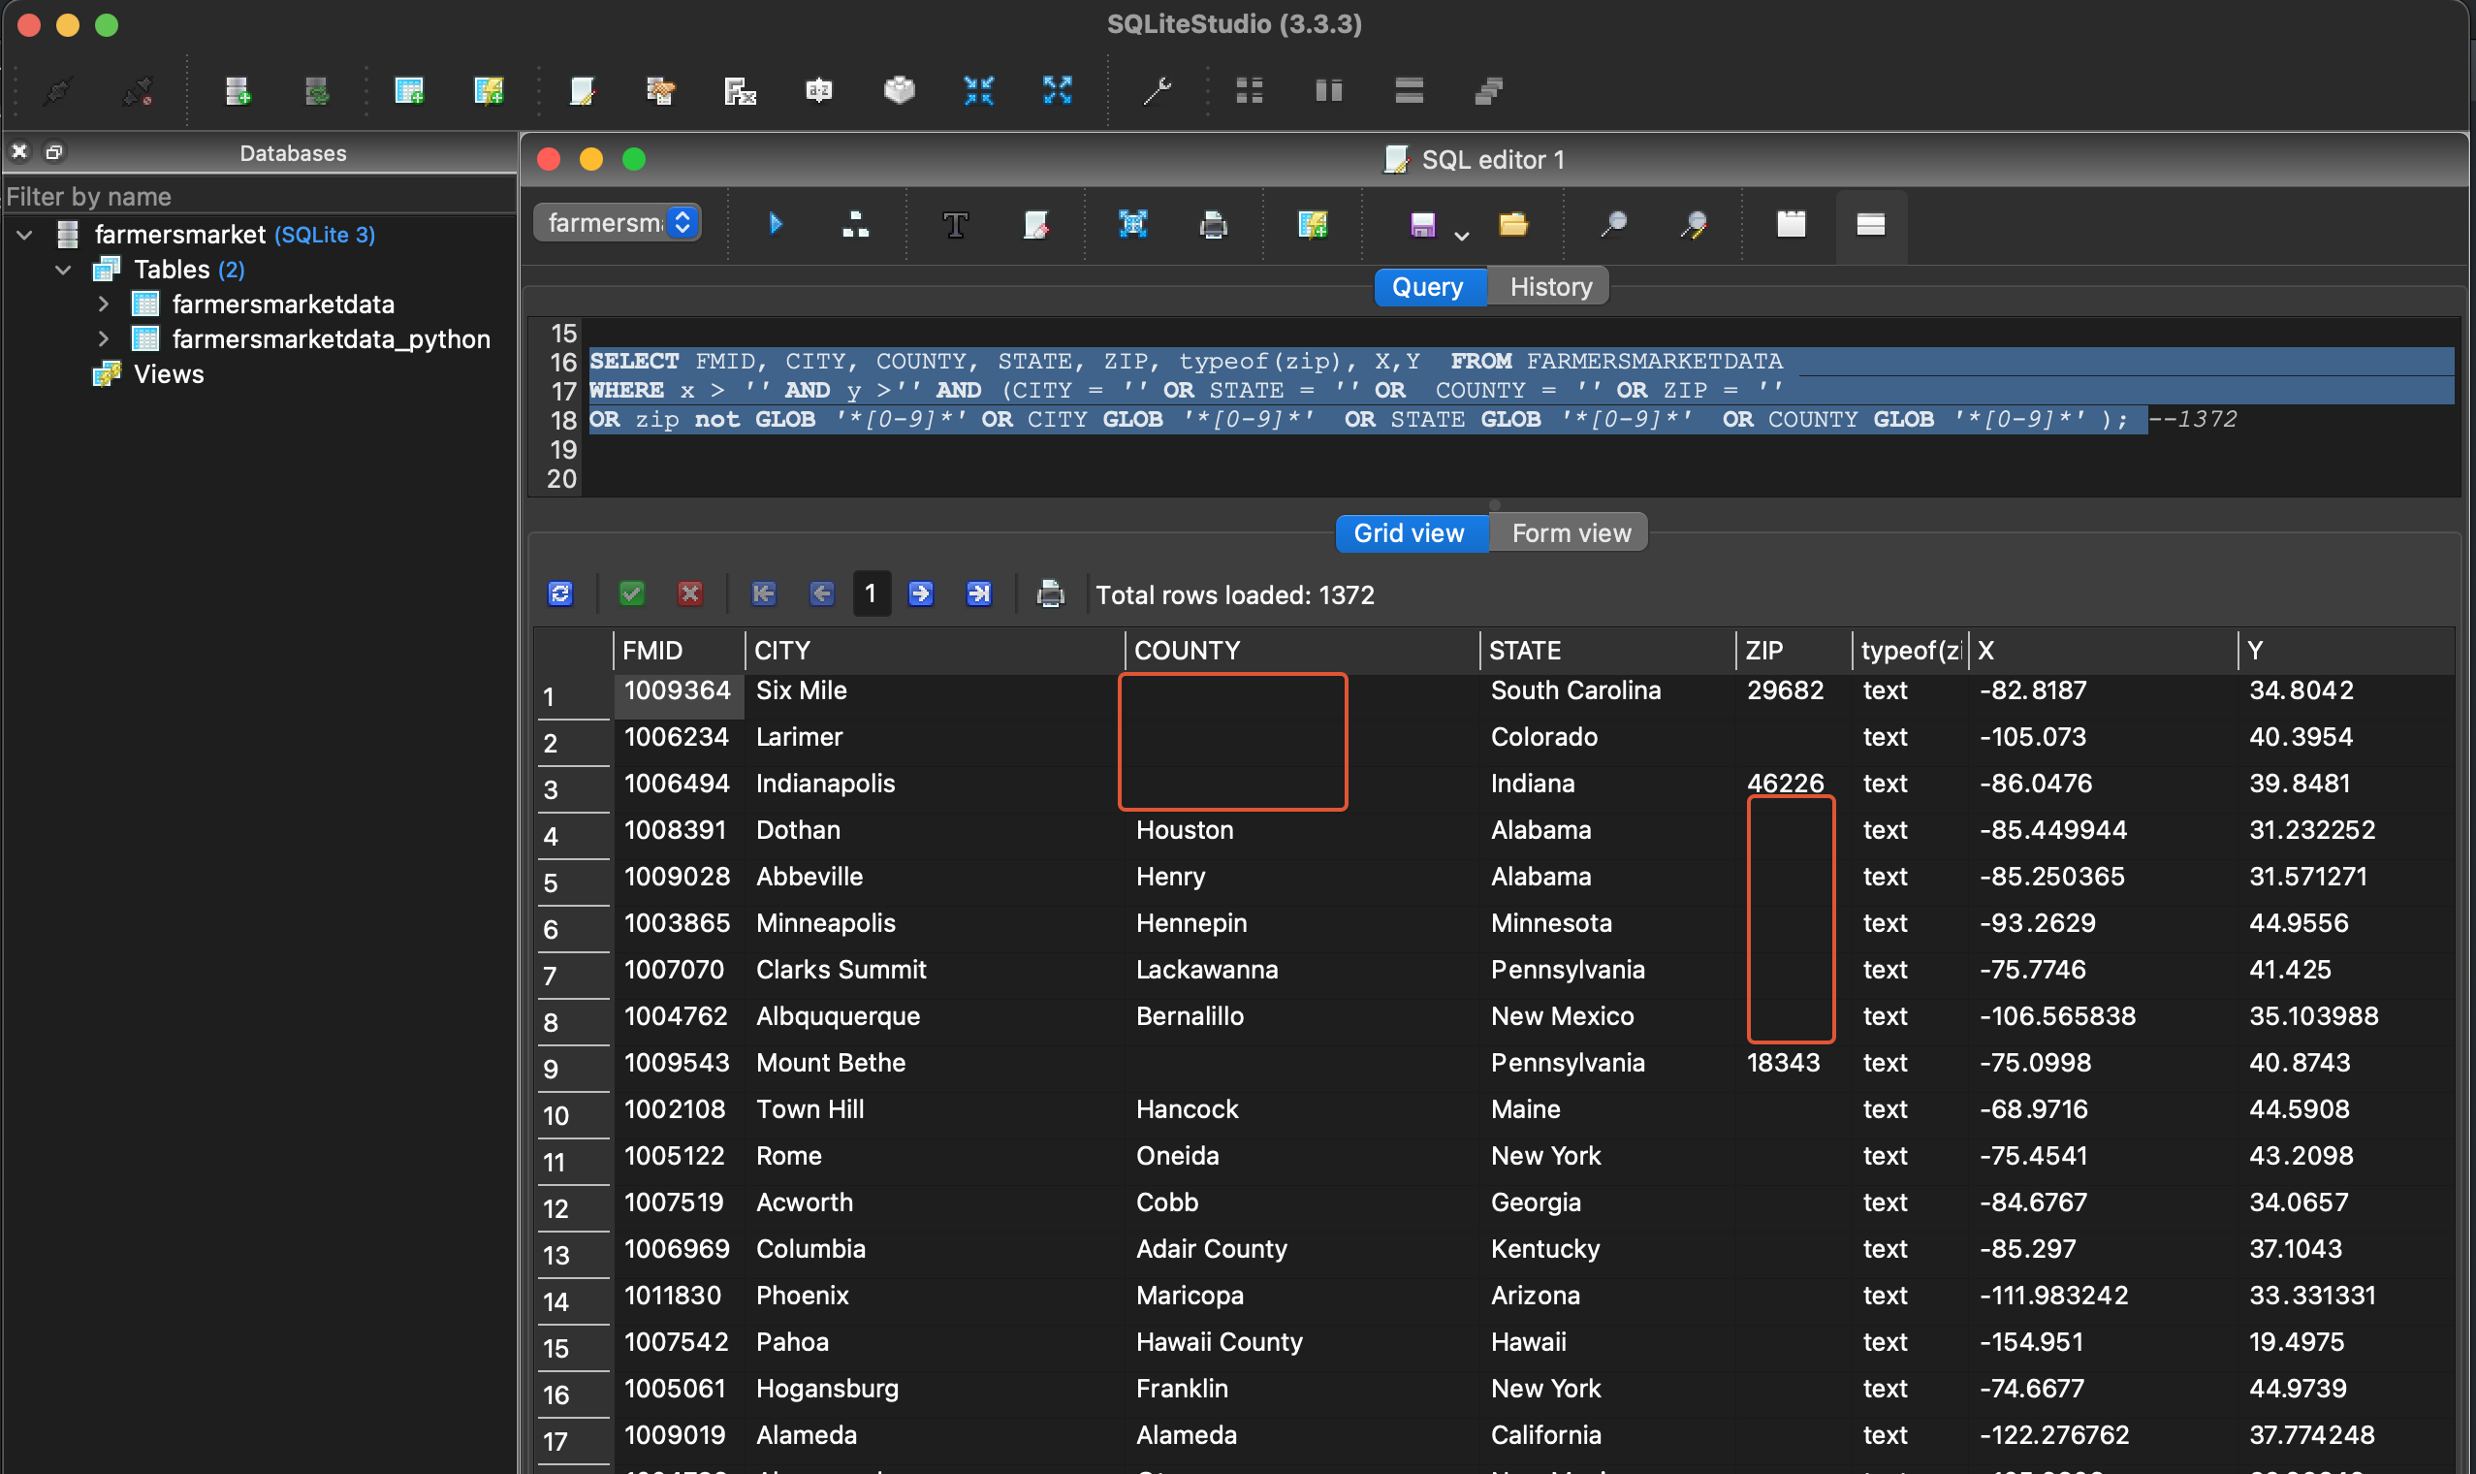

We are using the SearchEngine package to find the corresponding zipcode, city, state and county information from the available Latitude and longitude. The result of data correction is as below.

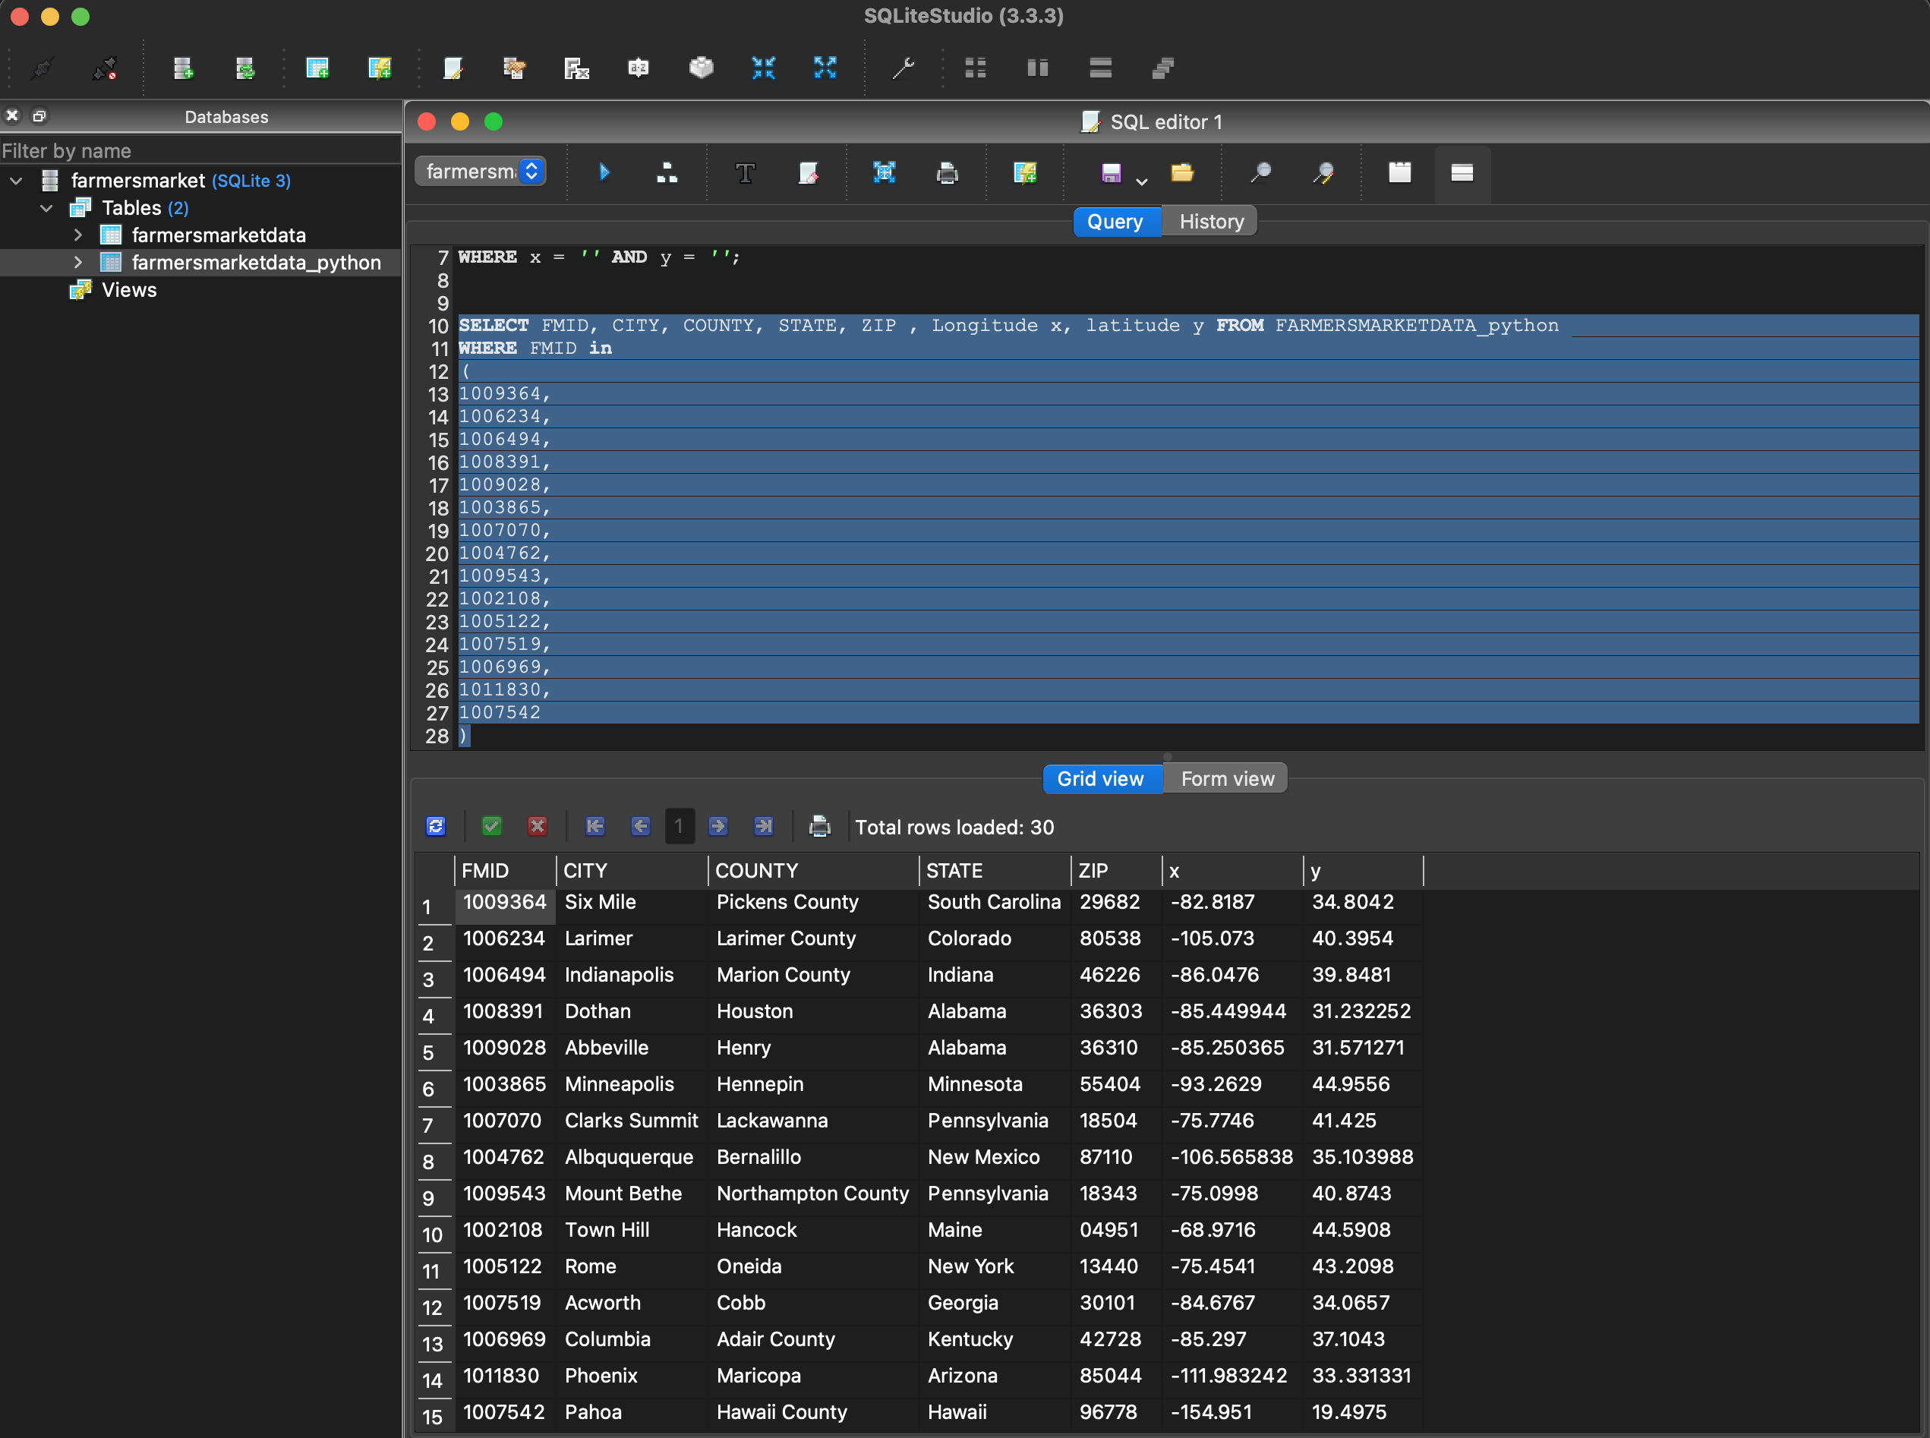

We observed that the library does not recognize geo coordinates in Alaska. Hence we further reused the zipcode to find the corresponding county, city information.

Finally we eliminate the rows with does not have any geocoordinates

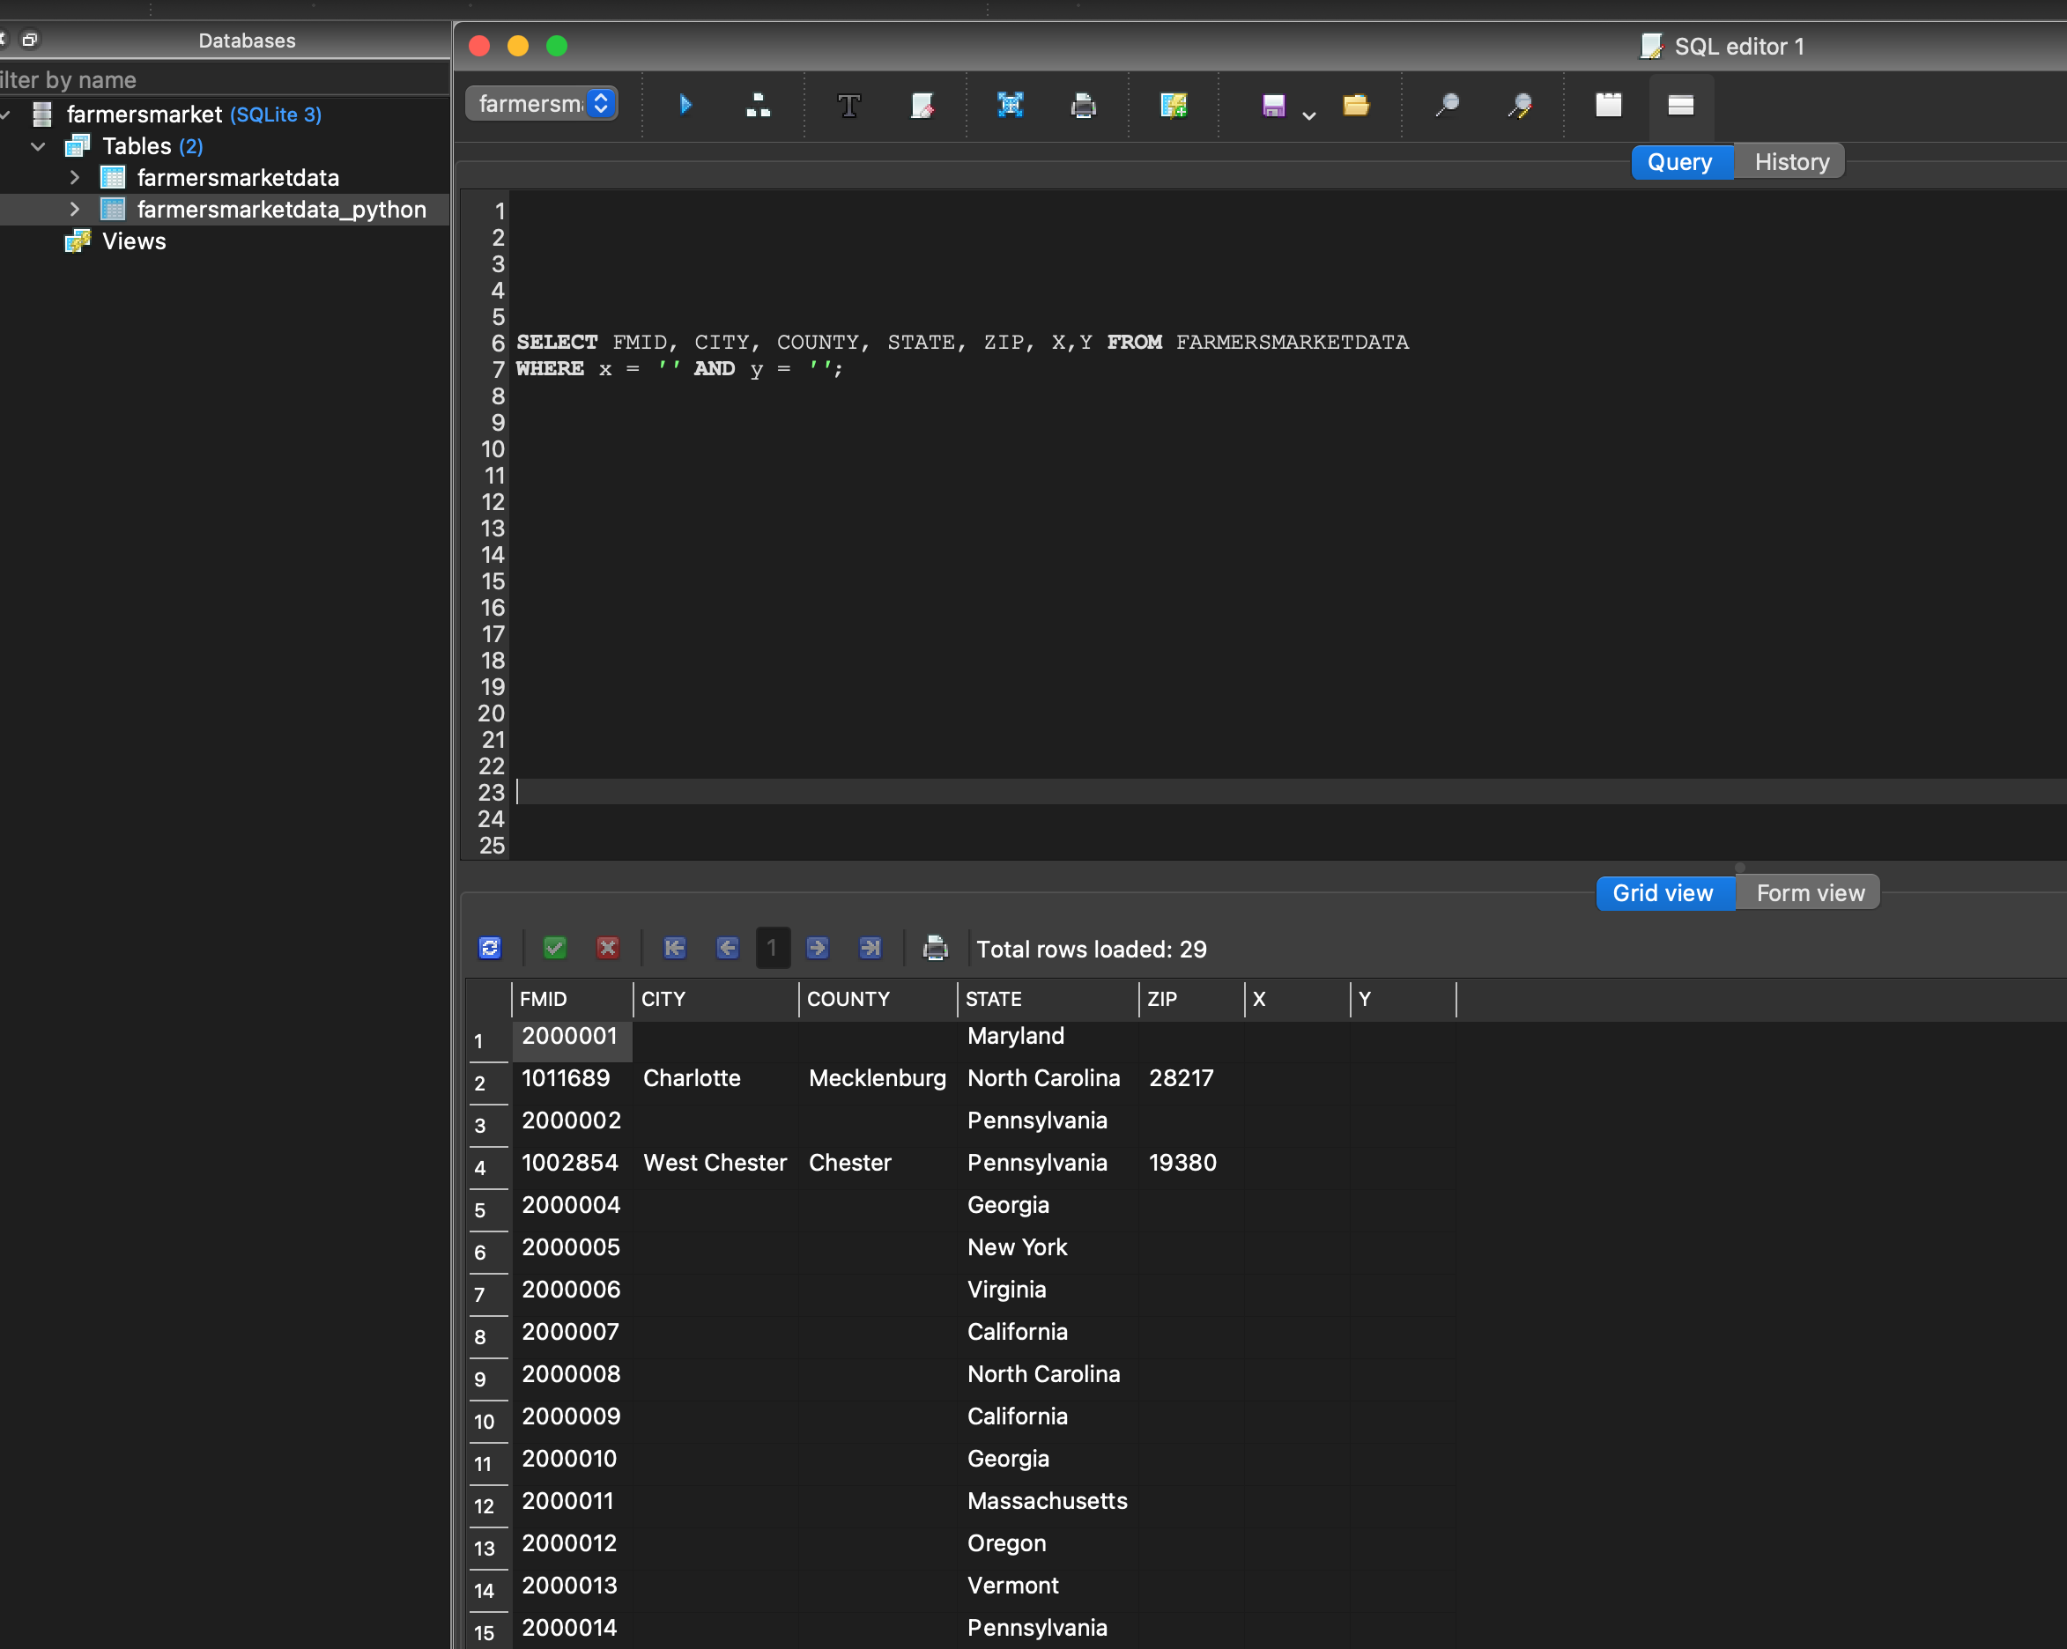

And Lastly, we rename the columns x and y to Longitude and Latitude respectively.

**Developing a relational schema**

**We need to add a brief summary of the steps involved with Creating the schema from the csv input.**

**Let’s add a screenshot** after creating the schema with sql lite editor with evidence that we ran the query here

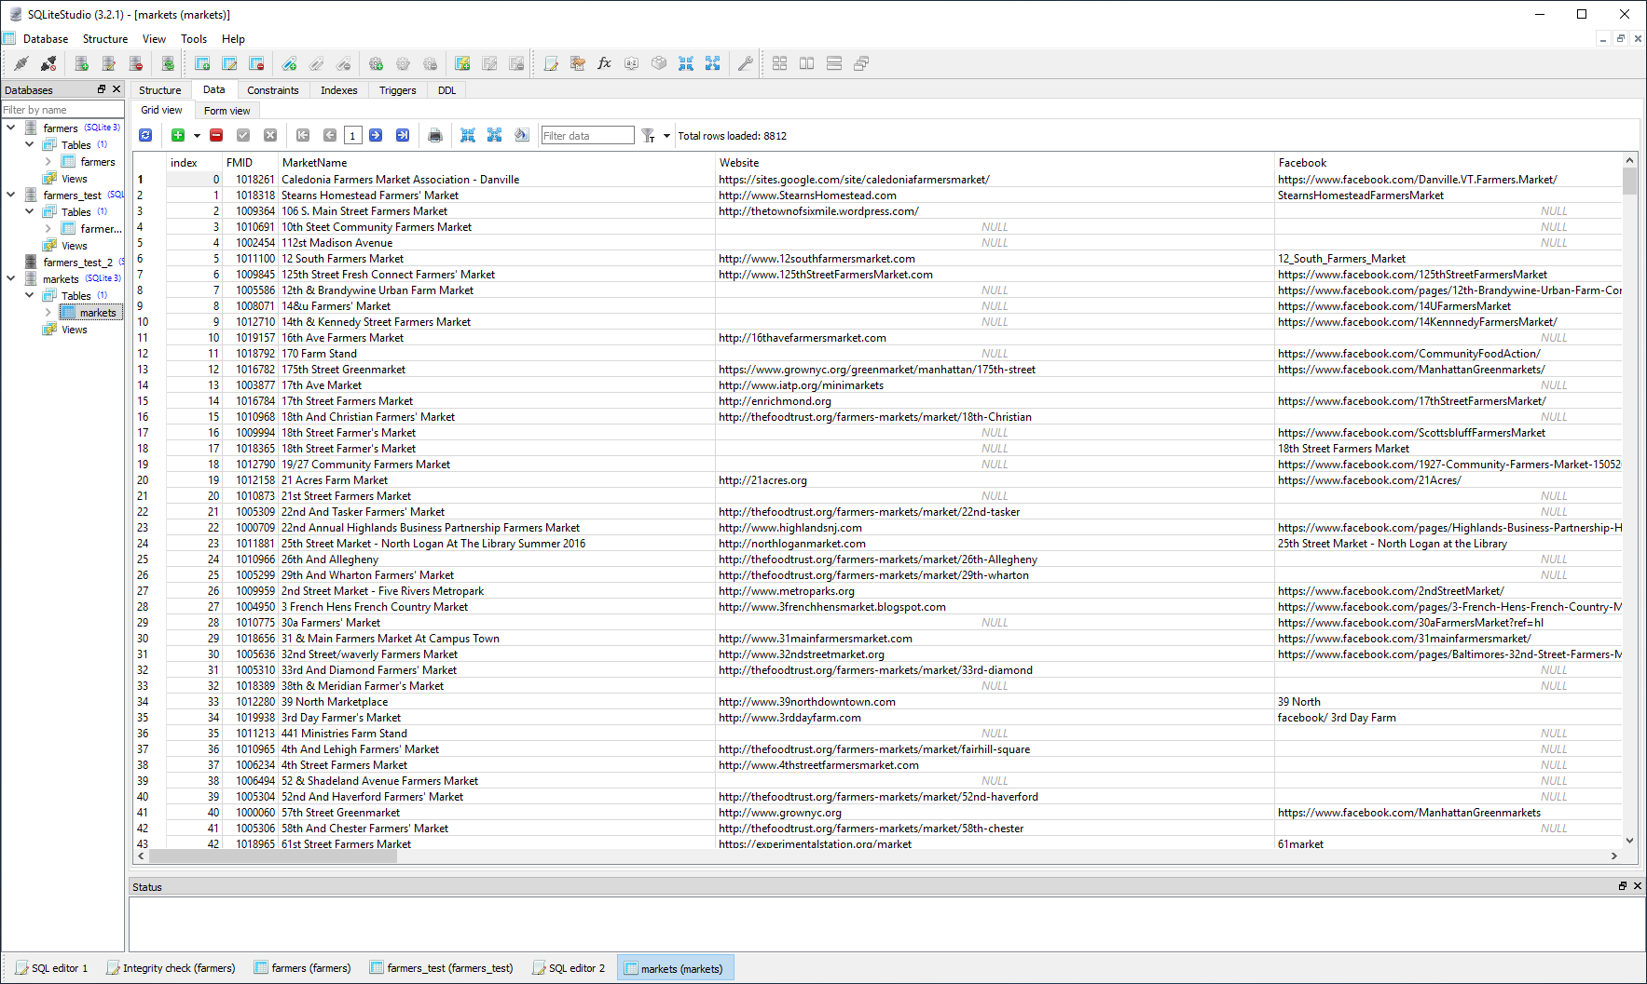

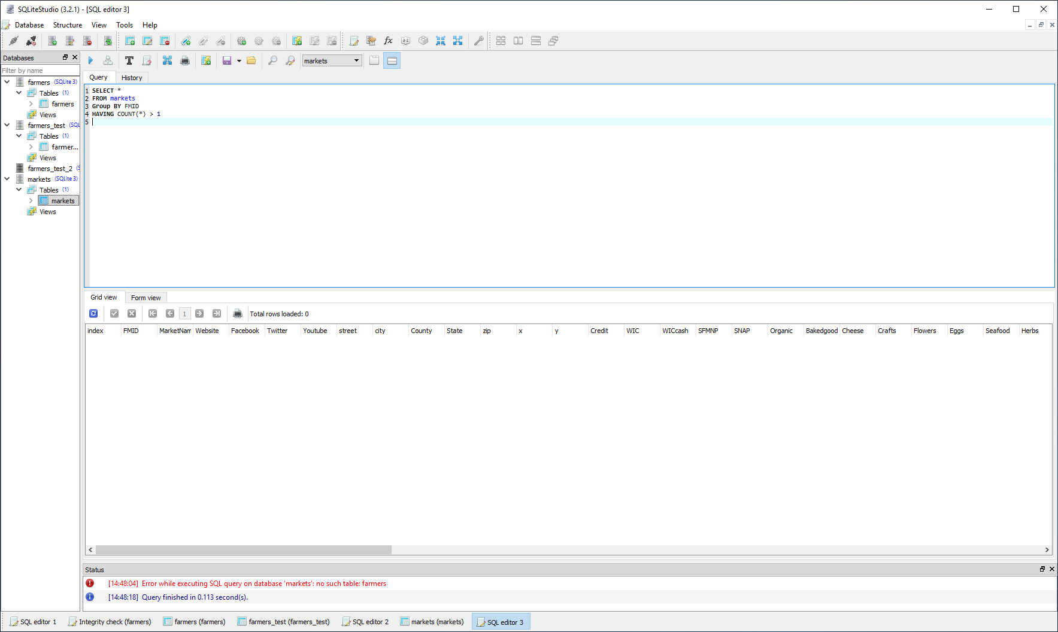

**Workflow Diagram**

We have translated openrefine JSON recipe to YesWorkflow diagram using OR2YWTool.

**Here are the steps:**

(base) Goutams-MBP:ProjectWork gdebnath$ **pip install or2ywtool**

….

….

Successfully installed or2ywtool-0.0.16

(base) Goutams-MBP:ProjectWork gdebnath$ **or2yw**

usage: or2yw [-h] [-i INPUT] [-o OUTPUT] [-t TYPE] [-ot OUTPUTTYPE]

[-java JAVA] [-dot DOT] [-title TITLE] [-desc DESCRIPTION]

OR2YW v0.0.16

optional arguments:

-h, --help show this help message and exit

-i INPUT, --input INPUT

openrefine json file

-o OUTPUT, --output OUTPUT

yesworkflow output file

-t TYPE, --type TYPE Workflow Type, Produce [serial,parallel,merge]

workflow, Default: serial

-ot OUTPUTTYPE, --outputtype OUTPUTTYPE

Output Type, Produce output [yw,gv,png,svg,pdf],

Default: yw

-java JAVA, --java JAVA

Java Path, if not initialized will use the java

installation environment path

-dot DOT, --dot DOT Dot Path, if not initialized will use the dot

installation environment path

-title TITLE, --title TITLE

Title for the Workflow

-desc DESCRIPTION, --description DESCRIPTION

Description for the Workflow

(base) Goutams-MBP:ProjectWork gdebnath$ **or2yw -i**

Data-Cleaning-cs513-Phase-2-Jul_12.docx

Data-Cleaning-cs513-Phase-2.docx

FarmersMarketDataCleaning.py

OpenRefineHistory.json

farmersmarkets-2017-01-10.csv

farmersmarkets_clean_openrefine.csv

farmersmarkets_clean_openrefine_python.csv

yw-editor-app-0.2.1.2-SNAPSHOT.jar

(base) Goutams-MBP:ProjectWork gdebnath$ **or2yw -i OpenRefineHistory.json -o** OpenRefineHistory.yw -t parallel

File OpenRefineHistory.yw generated.

(base) Goutams-MBP:ProjectWork gdebnath$ **dot -V**

dot - graphviz version 3.0.0 (20220226.1711)

(base) Goutams-MBP:ProjectWork gdebnath$ **or2yw -i OpenRefineHistory.json -ot pdf -o OpenRefineHistory.pdf -t parallel**

java found: java

dot found: dot

File OpenRefineHistory.pdf generated.

(base) Goutams-MBP:ProjectWork gdebnath$ **or2yw -i OpenRefineHistory.json -ot png -o OpenRefineHistory.png -t parallel**

java found: java

dot found: dot

File OpenRefineHistory.png generated.

Please find the Generated Workflow Diagram as below:



We will share the generated yw/pdf/png files as part of the supplemental package.

# Exploring the distribution of farmers markets in the US.

Used Python express library from Plotly on the cleaned dataset and below bar plot shows **Number of farmers market per State**

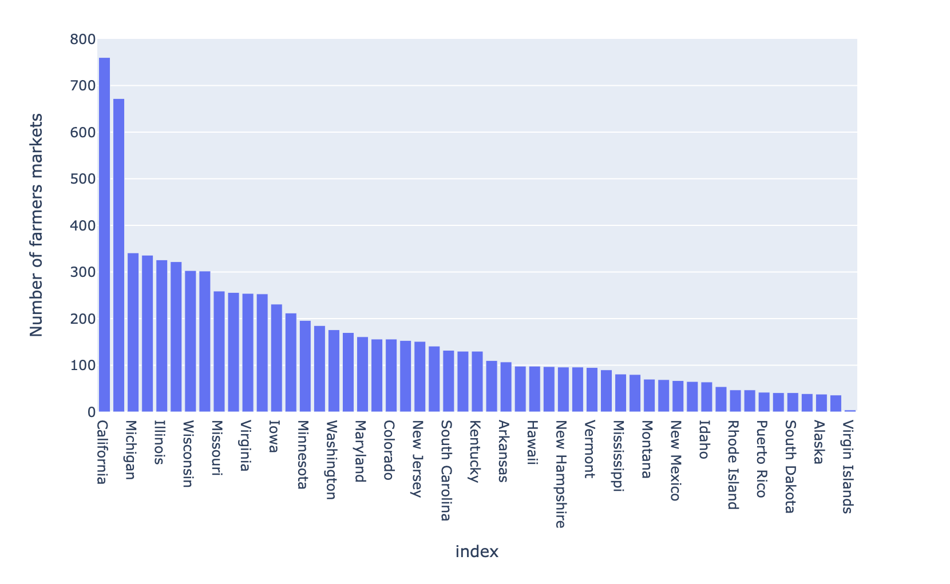

California and Michigan has most number of farmers markets whereas Virgin island has the least. This gives us a good indication of market availability for the states we are interested in.

Used Python graph_objects library from Plotly to plot the farmers market locations in US map.

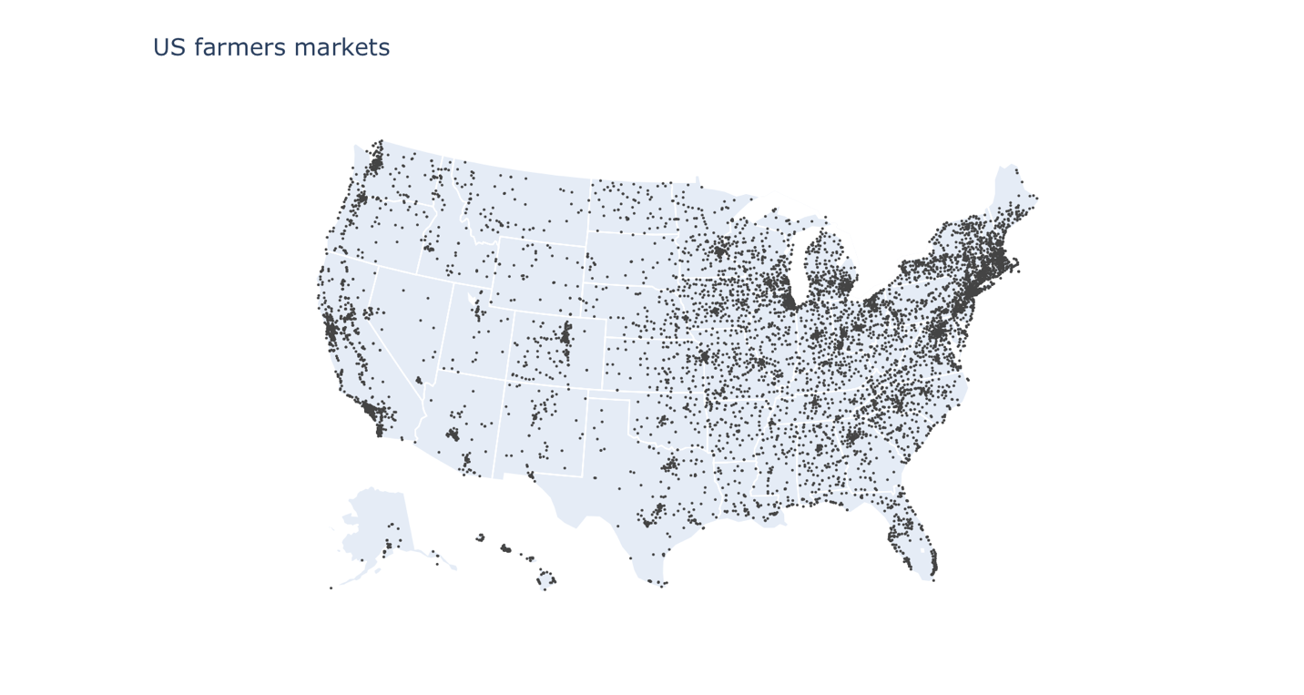

#### Observations:

* We can see that the southern region has a relatively moderate density of farmers markets throughout, with the states further to the east having a higher density.
* The mid-west states have a relatively low density of farmers markets throughout, however the states further to the east increase in density.
* The farmers markets of the western states are concentrated along the coastal states, with quite a low density across the rest of the region.
* The north-eastern states have the highest density of farmers markets throughout all of the states.